Exploratory Task Questionnaire

**What is your participant ID? ____________**

**How satisfied are you with your progress on the analysis task?**

(Fill one of the 7 bubbles)

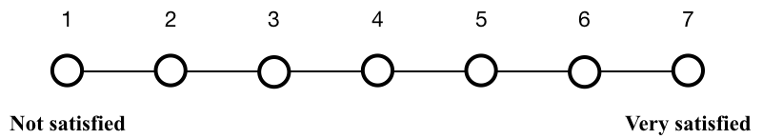

**How helpful was gathering in the exploratory programming task?**

(Fill one of the 7 bubbles)

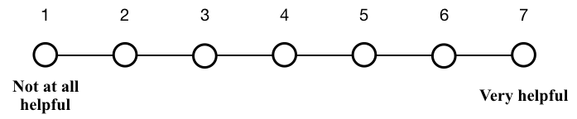

**Please explain (1-2 sentences).**

**What was the most helpful thing the gathering tool did for you (if applicable) (1-2 sentences).**

(continued on next page)

**How useful were each of the following gathering features during this exploratory programming task?** (Select one for each row)

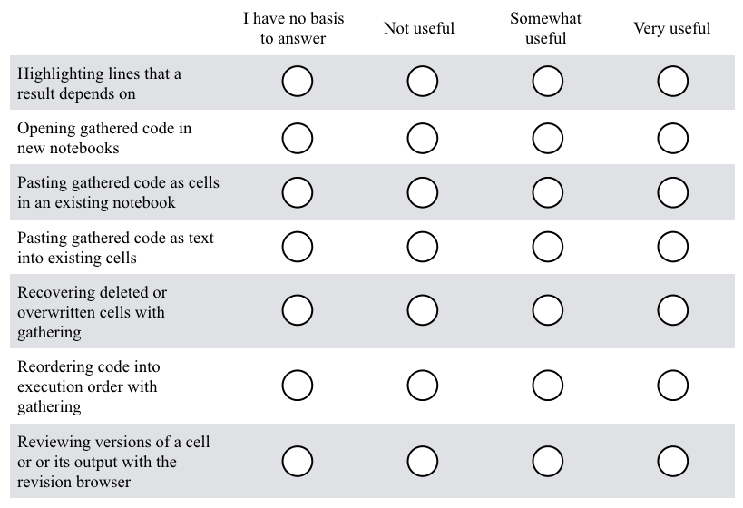

**Please explain (1-2 sentences).**

**What should this gathering tool support better to be more useful for you during your everyday programming work in Jupyter notebook?** (1-2 sentences)

**Did the tool ever behave in a way you didn’t expect? Please explain (1-2 sentences).**

Thank you for your feedback!